TRUE/FALSE (5 Marks. Half Mark for Each Question)

❌Q1. In Python, it’s possible to modify the value of a tuple element after it has been created.

✔️Q2. Everything in Python is an object.

✔️Q3. The Dependency Inversion Principle (DIP) suggests that both high-level and low-level modules should depend on abstractions, not concrete implementations, which promotes loose coupling and flexibility in the codebase.

❌Q4. The output of the following code snippet is
x = [[i * j for j in range(1, 2)] for i in range(1, 3)]
print(x)
[[1, 2]]
Feedback output
[[1], [2]]

✔️Q5. The output of the following
class Parent:
def __init__(self, name):
self.name = name
def greet(self):
return f"Hello, I am {self.name}."
class Child(Parent):
def __init__(self, name, age):
self.name = name
self.age = age
def greet(self):
return f"{super().greet()} I am {self.age} years old."
child = Child("Alice", 10)
print(child.greet())
is
Hello, I am Alice. I am 10 years old.

✔️Q6. Decorator and Proxy have similar structures, but very different intents.

❌Q7. In the State Design Pattern, state objects are completely independent and unaware of each other.
Feedback- that is the observer design pattern

✔️Q8. Facade and Mediator have similar jobs: they try to organize collaboration between lots of tightly coupled classes.

For the following code, answer the following two questions.
def safe_divide(x, y):
try:
return x / y
except ZeroDivisionError:
return None # Or you might want to raise a custom exception
import unittest
class TestExceptionHandling(unittest.TestCase):
def test_divide_by_zero(self):
with self.assertRaises(ZeroDivisionError):
safe_divide(5, 0)
def test_safe_division(self):
result = safe_divide(10, 2)
self.assertIsNone(result) # Assuming you return None on error
# Run the tests
unittest.main()

❌Q9 - The test_divide_by_zero unit test will pass.

❌Q10 - The test_safe_division unit test will pass.

MCQ (10 Marks. One Mark for Each Question)

Q1. Which of the following design patterns construct complex objects step by step.
A. Builder
B. Abstract Factory
C. Singleton
D. Factory

Q2. Which of the following design patterns address various ways of connecting senders and receivers of requests?
B. Chain of Responsibility, Observer and Strategy
C. Chain of Responsibility, Mediator and Strategy
C. Chain of Responsibility, Mediator and Observer
D. Mediator, Observer and Strategy

Q3. What is the output of the following code?

class SupportHandler:
"""
The base abstract handler for the chain of responsibility.
"""
def __init__(self, successor=None):
self._successor = successor
def handle_request(self, request):
"""
Handles the request if possible. Otherwise passes it to the successor.
"""
if self._can_handle(request):
self._process_request(request)
elif self._successor is not None:
print(f"{self.__class__.__name__} cannot handle. Passing to next handler...")
self._successor.handle_request(request)
else:
print("Request cannot be handled!")
def _can_handle(self, request):
raise NotImplementedError("Subclasses must implement this method")
def _process_request(self, request):
raise NotImplementedError("Subclasses must implement this method")
class Level1Support(SupportHandler):
def _can_handle(self, request):
return request.severity == "low"
def _process_request(self, request):
print(f"Level 1 Support: Handling request - {request}")
class Level2Support(SupportHandler):
def _can_handle(self, request):
return request.severity == "medium"
def _process_request(self, request):
print(f"Level 2 Support: Handling request - {request}")
class Level3Support(SupportHandler):
def _can_handle(self, request):
return request.severity == "high"
def _process_request(self, request):
print(f"Level 3 Support: Handling request - {request}")
class Request:
"""A simple request class"""
def __init__(self, description, severity):
self.description = description
self.severity = severity
def __str__(self):
return f"Request({self.description}, severity={self.severity})"
# Building the chain of responsibility
level1 = Level1Support()
level2 = Level2Support(level1)
level3 = Level3Support(level2)
# Sample requests
requests = [
Request("Basic printer issue", "low")
]
# Process the requests through the chain
for request in requests:
level3.handle_request(request) # Start with the highest level

Option A.
Level3Support cannot handle. Passing to next handler...
Level2Support cannot handle. Passing to next handler...
Level 1 Support: Handling request - Request(Basic printer issue, severity=low)
Option B.
Level 1 Support: Handling request - Request(Basic printer issue, severity=low)
Level2Support cannot handle. Passing to next handler...
Level3Support cannot handle. Passing to next handler...
Option C.
Level3Support cannot handle. Passing to next handler...
Level 2 Support: Handling request - Request(Basic printer issue, severity=low)
Option D.
Level1Support cannot handle. Passing to next handler...
Level2Support cannot handle. Passing to next handler...
Level 3 Support: Handling request - Request(Basic printer issue, severity=low)

Q4. Which design pattern is used in the following Duck simulator?

class Duck:
def __init__(self, fly_behavior=None, quack_behavior=None):
self._fly_behavior = fly_behavior
self._quack_behavior = quack_behavior
def perform_fly(self):
self._fly_behavior.fly()
def perform_quack(self):
self._quack_behavior.quack()
def swim(self):
print("All ducks float, even decoys!")
def display(self):
"""Each duck type will override this method to look different"""
raise NotImplementedError
class FlyBehavior:
"""Parent class for fly behaviors."""
def fly(self):
raise NotImplementedError
class FlyWithWings(FlyBehavior):
def fly(self):
print("I'm flying with wings!!")
class FlyNoWay(FlyBehavior):
def fly(self):
print("I can't fly :(")
class QuackBehavior:
"""Parent class for quack behaviors"""
def quack(self):
raise NotImplementedError
class Quack(QuackBehavior):
def quack(self):
print("Quack!")
class Squeak(QuackBehavior):
def quack(self):
print("Squeak...")
class MuteQuack(QuackBehavior):
def quack(self):
print("<< Silence >>")
class MallardDuck(Duck):
def display(self):
print("I'm a real Mallard duck")
class RubberDuck(Duck):
def display(self):
print("I'm a rubber duckie")
# Client code in action
mallard = MallardDuck(FlyWithWings(), Quack())
mallard.display()
mallard.perform_fly() # This duck can fly!
mallard.perform_quack()
rubber_duckie = RubberDuck(FlyNoWay(), Squeak())
rubber_duckie.display()
rubber_duckie.perform_fly() # This duck cannot fly :(
rubber_duckie.perform_quack()

Option A. - The Observer design pattern
Option B. - The Bridge design pattern
Option C. - The state design pattern
Option D. - The Strategy design pattern

Q5. Which of the following UML diagrams is the correct representation of the following code snippet?

import time
class TrafficLight:
def __init__(self, state) -> None:
self.state = state
def update(self):
"""
Updates the state of the traffic light
Red -> Green -> Yellow -> Red
"""
self.state = self.state.update()
def change_state(self):
self.state.set_context(self)
self.state.update()
class State:
def set_context(self, a_context):
self.context = a_context
class Red(State):
def __str__(self) -> str:
return "Red"
def update(self):
self.context.state = Green()
class Green(State):
def __str__(self) -> str:
return "Green"
def update(self):
self.context.state = Yellow()
class Yellow(State):
def __str__(self) -> str:
return "Yellow"
def update(self):
self.context.state = Red()
def main():
a_traffic_light = TrafficLight(Red())
print(a_traffic_light.state)
while True:
print("Updating the state of the traffic light")
a_traffic_light.change_state()
print(a_traffic_light.state)
time.sleep(1) # import time
main()
Use the following key to identify the correct UML diagram:
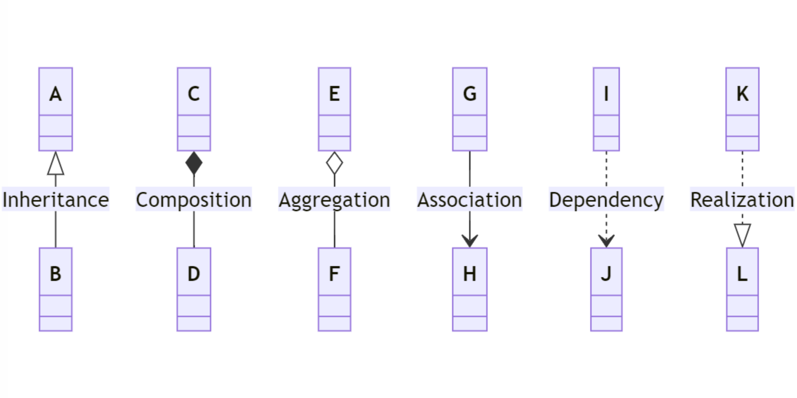

- Option A
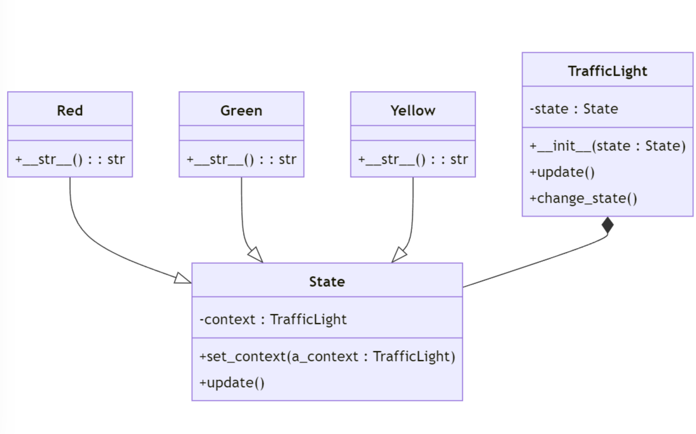
- Option B
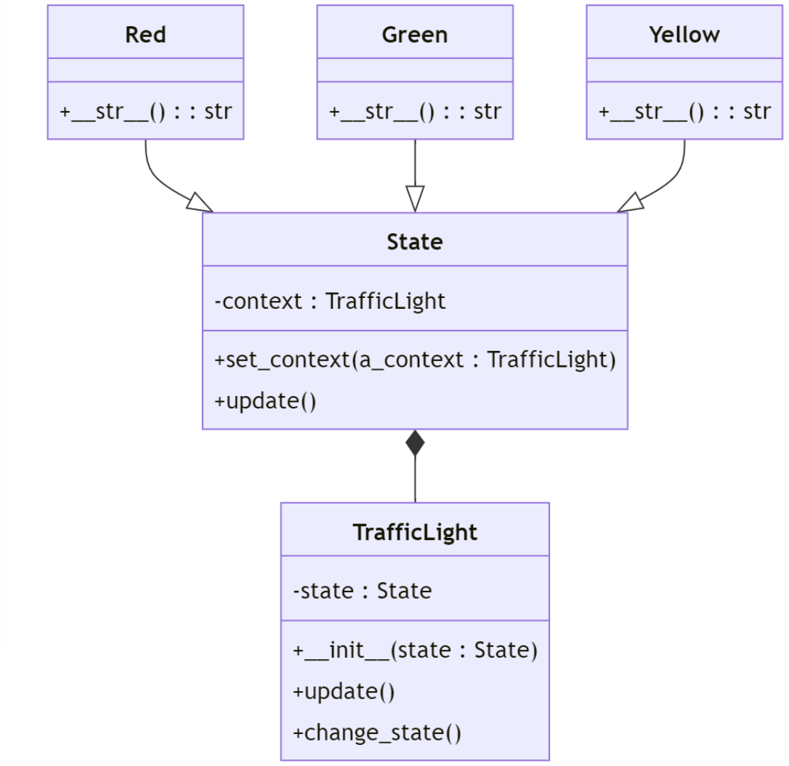
- Option C
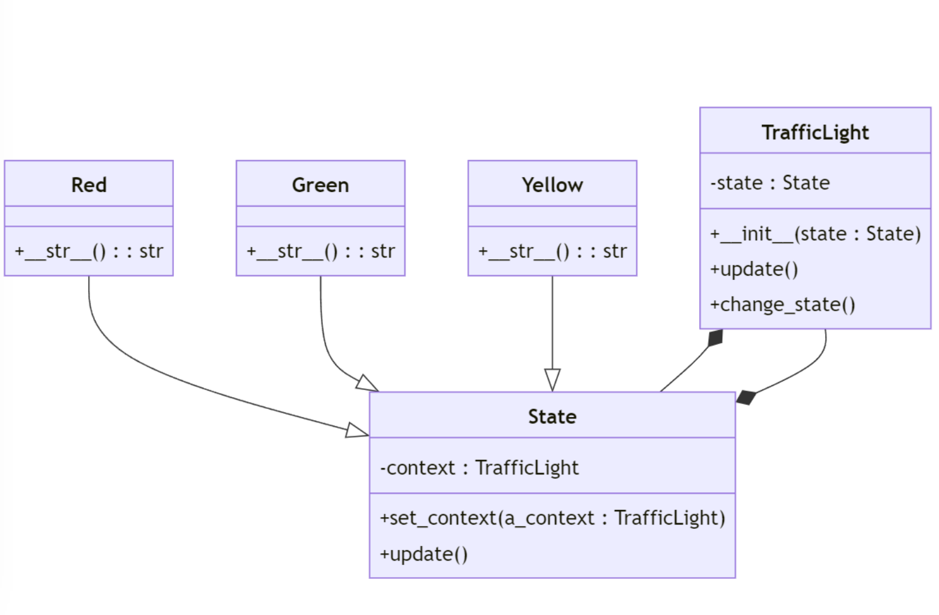

Q6. What is the output of the following code?

def data_source():
for i in range(10):
yield i
def f1(numbers):
for num in numbers:
yield num * 2
def f2(numbers):
for num in numbers:
if num % 2 == 0:
yield num
# Pipeline execution
pipeline = f2(f1(data_source()))
for result in pipeline:
print(result)
Option A:
0
4
8
12
16
Option B:
0
2
4
6
8
10
12
14
16
18
Option C:
0
2
4
6
8
10
12
14
16
18
20
Option D:
0
4
8
12
16
20

Q7. What is roughly the total time of running the following code?
import asyncio
import time
class Subject:
def __init__(self):
self._observers = []
def attach(self, observer):
if observer not in self._observers:
self._observers.append(observer)
def detach(self, observer):
if observer in self._observers:
self._observers.remove(observer)
async def notify(self, message):
for observer in self._observers:
await observer.update(message)
class Observer:
async def update(self, message):
await asyncio.sleep(0.5)
print(f"Observer received: {message}")
async def main():
x = time.perf_counter()
subject = Subject()
observer_a = Observer()
observer_b = Observer()
subject.attach(observer_a)
subject.attach(observer_b)
task_notofiy = asyncio.create_task(subject.notify("Hello observers!"))
another_task_notfiy = asyncio.create_task(subject.notify("Another message"))
await task_notofiy
await another_task_notfiy
y = time.perf_counter()
print(f"Total time: {y-x}")
if __name__ == "__main__":
asyncio.run(main())
Option A - 1 second
Option B - .5 seconds
Option C - 2 seconds

Q8. Which of the following code snippets is a proper implementation of the Proxy design pattern?
Option A.
class SensitiveDatabase:
def __init__(self):
self._data = "Top Secret Data"
def read_data(self):
print("Accessing actual database...")
return self._data
class DatabaseProxy:
def __init__(self):
self._database = SensitiveDatabase()
self._authorized_users = ["admin", "manager"]
def read_data(self, username):
return self._database.read_data()
# driver code
database = DatabaseProxy()
print(database.read_data("admin"))
Option B.
class SensitiveDatabase:
def __init__(self):
self._data = "Top Secret Data"
def read_data(self):
print("Accessing actual database...")
return self._data
class DatabaseProxy:
def __init__(self):
self._database = SensitiveDatabase()
self._authorized_users = ["admin", "manager"]
def read_data(self, username):
if username in self._authorized_users:
return self._database.read_data()
else:
print("Access denied!")
# driver code
database = DatabaseProxy()
print(database.read_data("admin"))
Option C.
class SensitiveDatabase:
def __init__(self):
self._data = "Top Secret Data"
def read_data(self):
print("Accessing actual database...")
return self._data
class DatabaseProxy:
def __init__(self):
self._database = SensitiveDatabase()
self._authorized_users = ["admin", "manager"]
def read_data(self, username):
if username in self._authorized_users:
return self._database.read_data()
else:
print("Access denied!")
def get_database(self):
return self._database
# driver code
database = DatabaseProxy()
print(database.read_data("admin"))

Feedback
- Option A is wrong.
Bypassing the Proxy: The DatabaseProxy class should not provide a way to directly access the SensitiveDatabase. The proxy should be the only way to access the sensitive data, and it should control the access based on the user’s credentials.
- Option C is wrong.
Also Bypassing the Proxy: because of the usage of ungaurded getter get_database() .

Q9. In Bridge design pattern, we say that the Abstractions control the Implementation. For the following code snippet, which class is the Abstraction and which class is the Implementation?
class Shape:
def draw(self):
pass
class Renderer:
def render_circle(self, radius):
pass
class Circle(Shape):
def __init__(self, x, y, radius, renderer):
self.x = x
self.y = y
self.radius = radius
self.renderer = renderer
def draw(self):
self.renderer.render_circle(self.radius)
# ... Similar code for other shapes (Square, Triangle, etc.)
class RasterRenderer(Renderer):
def render_circle(self, radius):
print("Drawing a raster circle")
class VectorRenderer(Renderer):
def render_circle(self, radius):
print("Drawing a vector circle")
raster_circle = Circle(0, 0, 5, RasterRenderer())
raster_circle.draw() # Output: Drawing a raster circle
Option A.
- Abstraction: Shape, Implementation: Renderer
Option B.
- Abstraction: Renderer, Implementation: Shape

Feedback
In the Bridge design pattern, the Abstraction class controls the Implementation class. In the given code snippet, the Shape class is the Abstraction class, and the Renderer class is the Implementation class. The Shape class defines the draw method, which is implemented by the Renderer class. The Circle class is a Shape subclass that uses the Renderer class to render the circle. The RasterRenderer and VectorRenderer classes are concrete implementations of the Renderer class, and the Circle class uses them to render the circle.

Q10. For the following UML, which design pattern is being implemented?
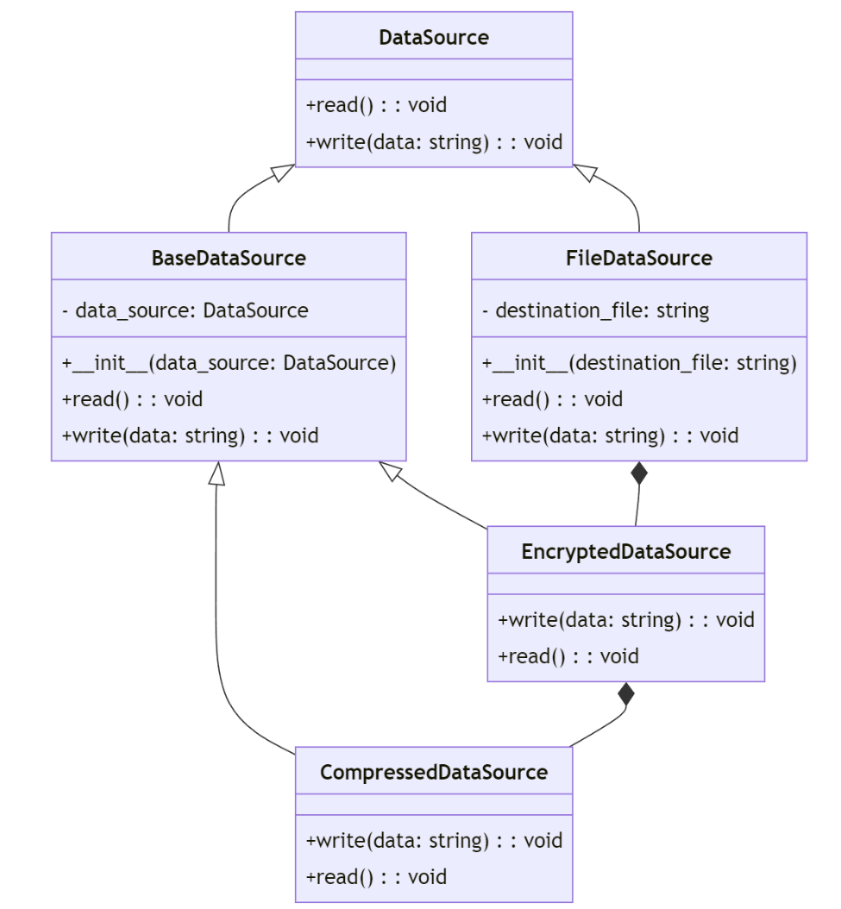
Option A. - The Observer design pattern
Option B. - The Strategy design pattern
Option C. - The Decorator design pattern
Option D. - The state design pattern

Feedback
This is an example from the slides. I just drew the UML.

What is the Output? (3 Marks)

What is a probable (likely) output of the following code?
import logging
import concurrent.futures
import time
class FakeDatabase:
def __init__(self):
self.value = 0
def update(self, name):
print("Thread %s: starting update"% name)
local_copy = self.value
local_copy += 1
time.sleep(0.1)
self.value = local_copy
print("Thread %s: finishing update"% name)
if __name__ == "__main__":
database = FakeDatabase()
print("Testing update. Starting value is %d."% database.value)
with concurrent.futures.ThreadPoolExecutor(max_workers=2) as executor:
for index in range(2):
executor.submit(database.update, index)
print("Testing update. Ending value is %d."% database.value)

Answer
Testing update. Starting value is 0.
Thread 0: starting update
Thread 1: starting update
Thread 1: finishing update
Thread 0: finishing update
Testing update. Ending value is 1.
or
Testing update. Starting value is 0.
Thread 0: starting update
Thread 1: starting update
Thread 0: finishing update
Thread 1: finishing update
Testing update. Ending value is 1.

Short Written Questions (5 Marks)

Q1. (3 Marks) Complete the Intent and Use When columns of the following table for the Strategy, State, and Bridge design patterns. Use single short sentences to complete the Intent and Use When columns.

Summary Table
Design Pattern | Intent | Use When
Strategy
State
Bridge

Answer

Summary Table
Design Pattern | Intent | Use When
Strategy | Select algorithms at runtime | Behavior needs to be selected/changed dynamically
State | Model state-dependent behavior | Object’s behavior tightly tied to its internal state
Bridge | Separate abstraction from implementation for independent variation | Multiple implementations or platforms to work with

Q2. (2 Marks) Write a comprehension to generate the following output.
[(5, 'apple'), (6, 'banana'), (6, 'orange'), (4, 'kiwi'), (9, 'pineapple')]
from the following list
words = ["apple", "banana", "orange", "kiwi", "pineapple"]

Anwser
# Generating a sequence of tuples containing the lengths of words and the words themselves
words = ["apple", "banana", "orange", "kiwi", "pineapple"]
word_lengths = [(len(word), word) for word in words]
print(word_lengths)

Guided Written Question (6 Marks)
Rewrite the following code using the decorator pattern using the suggested UML diagram.
The code defines a system for representing beverages with customizable options (condiments) and associated costs. It allows you to create different base beverages (like DarkRoast or HouseBlend) and add condiments with the ability to override default condiment prices.

class Beverage:
def __init__(self):
self.description = "Unknown Beverage"
self.base_cost = 0.0
self.has_milk = False
self.has_mocha = False
self.has_soy = False
self.has_whip = False
self.condiments_cost_table = {
"milk": 0.10, # Default costs
"mocha": 0.20,
"soy": 0.15,
"whip": 0.10,
}
def get_description(self):
desc = self.description
if self.has_milk:
desc += ", Milk"
if self.has_mocha:
desc += ", Mocha"
if self.has_soy:
desc += ", Soy"
if self.has_whip:
desc += ", Whip"
return desc
def cost(self, **kwargs):
cost = self.base_cost
if self.has_milk:
cost += self.condiments_cost_table["milk"]
if self.has_mocha:
cost += self.condiments_cost_table["mocha"]
if self.has_soy:
cost += self.condiments_cost_table["soy"]
if self.has_whip:
cost += self.condiments_cost_table["whip"]
# Override default costs with custom costs
for condiment, custom_cost in kwargs.items():
cost += custom_cost
cost -= self.condiments_cost_table[condiment]
return cost
class DarkRoast(Beverage):
def __init__(self):
super().__init__()
self.description = "Dark Roast Coffee"
self.base_cost = 0.99
class HouseBlend(Beverage):
def __init__(self):
super().__init__()
self.description = "House Blend Coffee"
self.base_cost = 0.89
# Example usage
beverage = DarkRoast()
beverage.has_mocha = True
beverage.has_whip = True
beverage.has_soy = True
print(beverage.get_description()) # Output: Dark Roast Coffee, Mocha, Whip, Soy
print(beverage.cost(soy=.12)) # Output: 1.41 (0.99 base + 0.20 mocha + 0.10 whip + 0.12 soy)

Here is a suggested UML diagram for the decorator pattern.

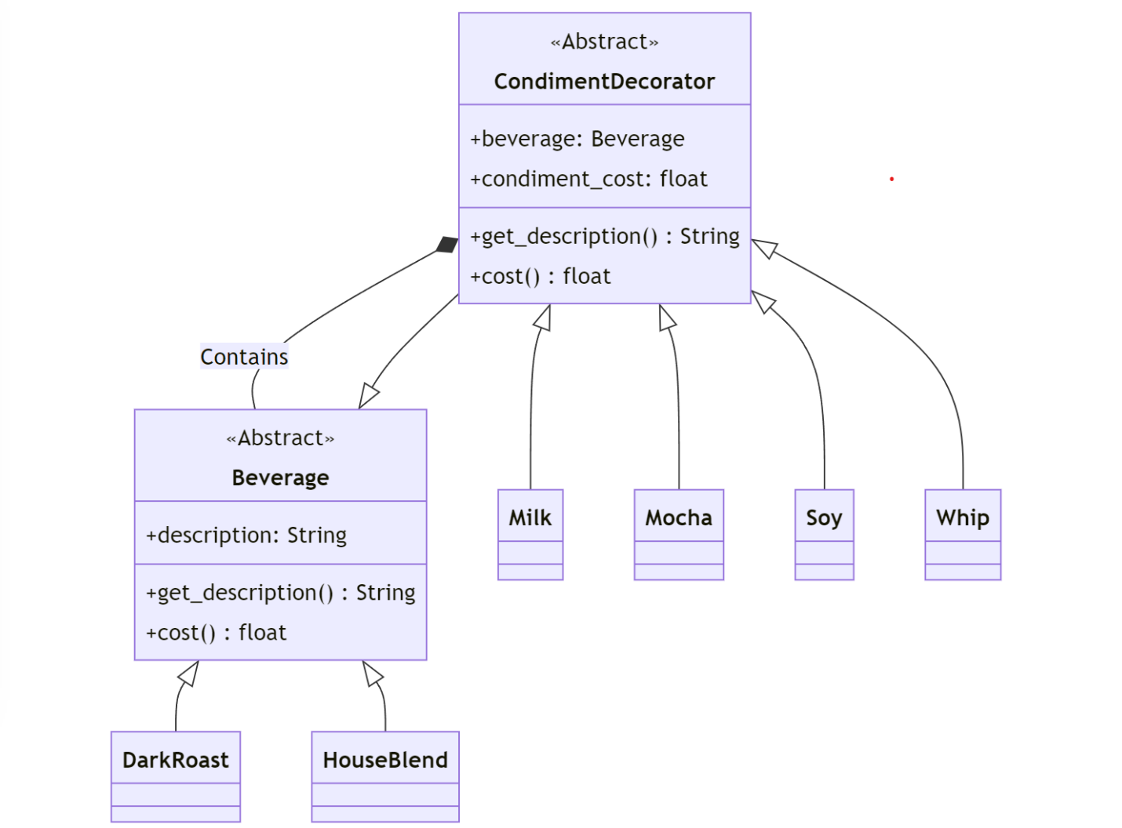

Step 1 – (1 Mark) Create the Beverage class.

class Beverage(ABC):
"""Abstract base class for beverages"""
def __init__(self):
self.description = "Unknown Beverage"
def get_description(self):
return self.description
@abstractmethod
def cost(self):
pass
@abstractmethod
def cost(self):
pass
class Beverage(ABC):
"""Abstract base class for beverages"""
def get_description(self):
return self.description
def __init__(self):
self.description = "Unknown Beverage"

Step 2 – (1 Mark) Update the Beverage Concrete classes.
class HouseBlend(Beverage):

class DarkRoast(Beverage):
def __init__(self):
super().__init__()
self.description = "Dark Roast Coffee"
def cost(self):
return 0.99
class HouseBlend(Beverage):
def __init__(self):
super().__init__()
self.description = "House Blend Coffee"
def cost(self):
return 0.89
def cost(self):
return 0.89
def __init__(self):
super().__init__()
self.description = "Dark Roast Coffee"

class DarkRoast(Beverage):

def __init__(self):
super().__init__()
self.description = "House Blend Coffee"
def cost(self):
return 0.99

Step 3 – (1 Mark) Create the CondimentDecorator class

class CondimentDecorator(Beverage):
"""
Base class for condiment decorators (with argument)
"""
def __init__(self, beverage, condiment_cost):
super().__init__()
self.beverage = beverage
self.condiment_cost = condiment_cost
@abstractmethod
def cost(self):
pass

class CondimentDecorator(Beverage):
"""
Base class for condiment decorators (with argument)
"""
def __init__(self, beverage, condiment_cost):
super().__init__()
self.beverage = beverage
self.condiment_cost = condiment_cost
@abstractmethod
def cost(self):
pass

Step 4 – (2 Marks) Create the concrete decorator classes.

class Milk(CondimentDecorator):
def __init__(self, beverage, custom_cost=0.10):
super().__init__(beverage, custom_cost)
def get_description(self):
return self.beverage.get_description() + ", " + "Milk"
def cost(self):
return self.beverage.cost() + self.condiment_cost
class Mocha(CondimentDecorator):
def __init__(self, beverage, custom_cost=0.20):
super().__init__(beverage, custom_cost)
def get_description(self):
return self.beverage.get_description() + ", " + "Mocha"
def cost(self):
return self.beverage.cost() + self.condiment_cost
class Soy(CondimentDecorator):
def __init__(self, beverage, custom_cost=0.15):
super().__init__(beverage, custom_cost)
def get_description(self):
return self.beverage.get_description() + ", " + "Soy"
def cost(self):
return self.beverage.cost() + self.condiment_cost
class Whip(CondimentDecorator):
def __init__(self, beverage, custom_cost=0.10):
super().__init__(beverage, custom_cost)
def get_description(self):
return self.beverage.get_description() + ", " + "Whip"
def cost(self):
return self.beverage.cost() + self.condiment_cost
class Mocha(CondimentDecorator):
def __init__(self, beverage, custom_cost=0.20):
super().__init__(beverage, custom_cost)
class Milk(CondimentDecorator):
def __init__(self, beverage, custom_cost=0.10):
super().__init__(beverage, custom_cost)

def get_description(self):
return self.beverage.get_description() + ", " + "Whip"
def get_description(self):
return self.beverage.get_description() + ", " + "Soy"
def cost(self):
return self.beverage.cost() + self.condiment_cost
class Soy(CondimentDecorator):
def __init__(self, beverage, custom_cost=0.15):
super().__init__(beverage, custom_cost)

def get_description(self):
return self.beverage.get_description() + ", " + "Milk"

def get_description(self):
return self.beverage.get_description() + ", " + "Mocha"
class Whip(CondimentDecorator):
def __init__(self, beverage, custom_cost=0.10):
super().__init__(beverage, custom_cost)

Step 5 – (1 Mark) Update the example usage.

# Example usage
beverage = DarkRoast()
beverage = Mocha(beverage) # Add Mocha with default cost
beverage = Whip(beverage) # Add Whip with default cost
beverage = Soy(beverage, 0.12) # Add Soy with a custom cost
print(beverage.get_description()) # Output: Dark Roast Coffee, Mocha, Whip, Soy
print(beverage.cost()) # Output: 1.41 (0.99 base + 0.20 mocha + 0.10 whip + 0.12 soy)

print(beverage.get_description())

beverage = Soy(beverage, 0.12)
beverage = Mocha(beverage)

print(beverage.cost())
beverage = DarkRoast()
beverage = Whip(beverage)

